Consent and Adding Minors in The FloodLAMP App

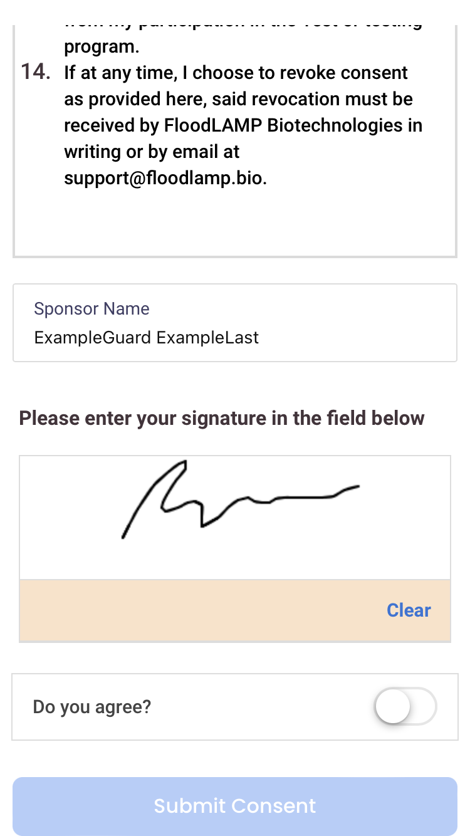
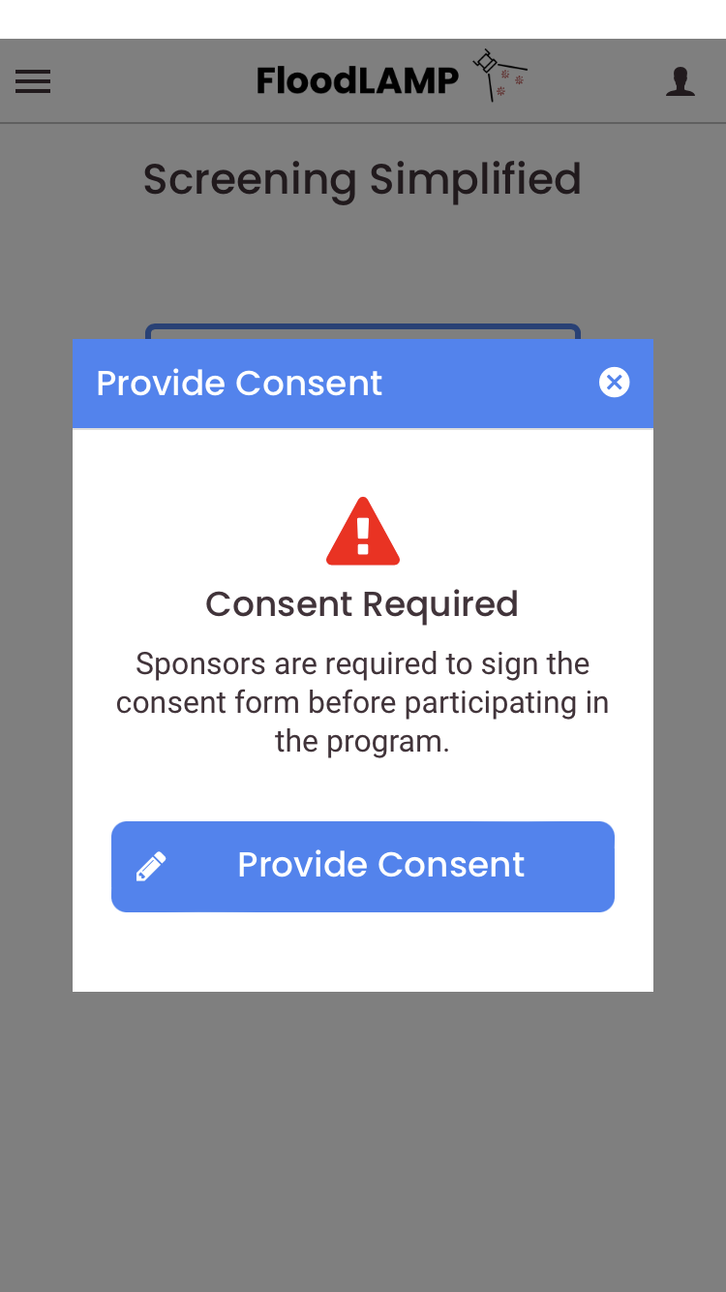
After creating your account via floodlamp.bio/register-household/, log into the FloodLAMP App and then read and sign the Consent Form.
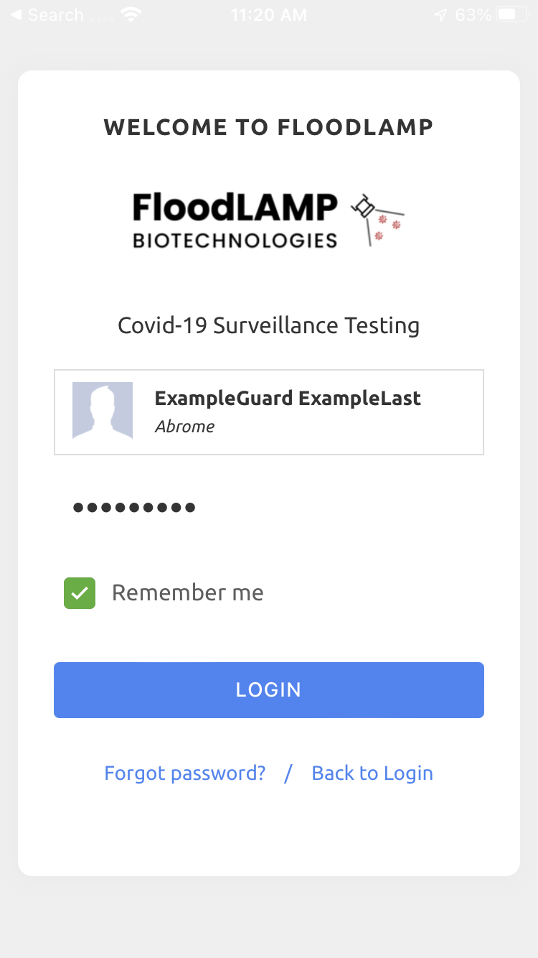

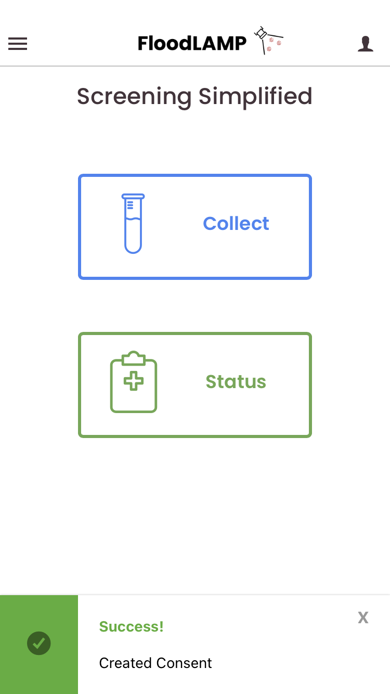
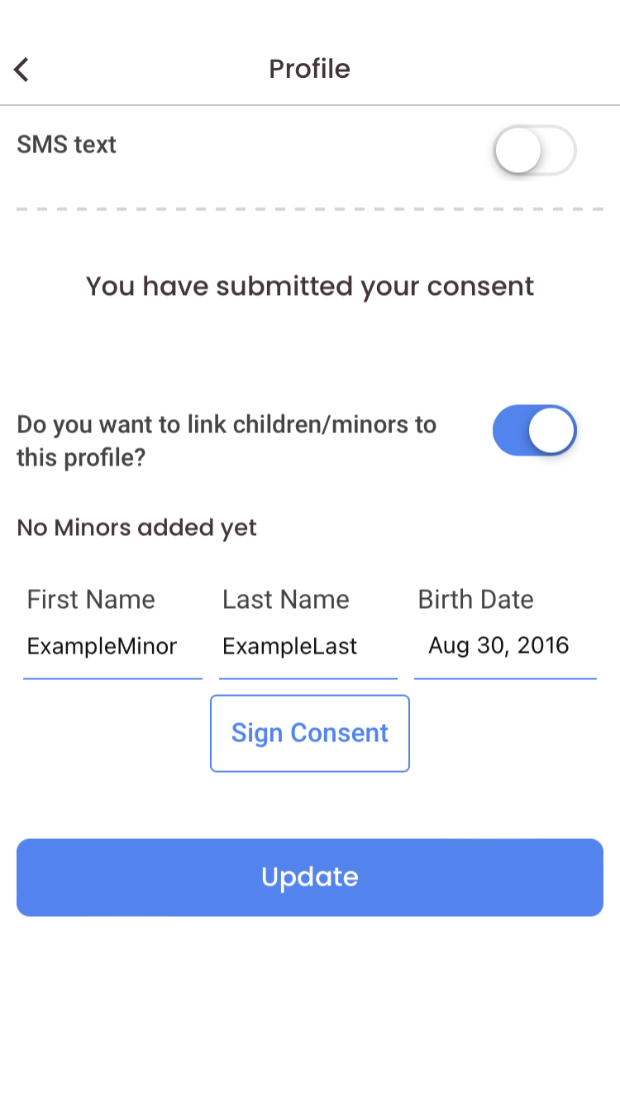
Next, navigate to the profile screen, scroll to the bottom, and select the option to add minors to your profile. Enter the minor’s name and birth date into the fields that appear and hit “Sign Consent” to be prompted with the minor consent.

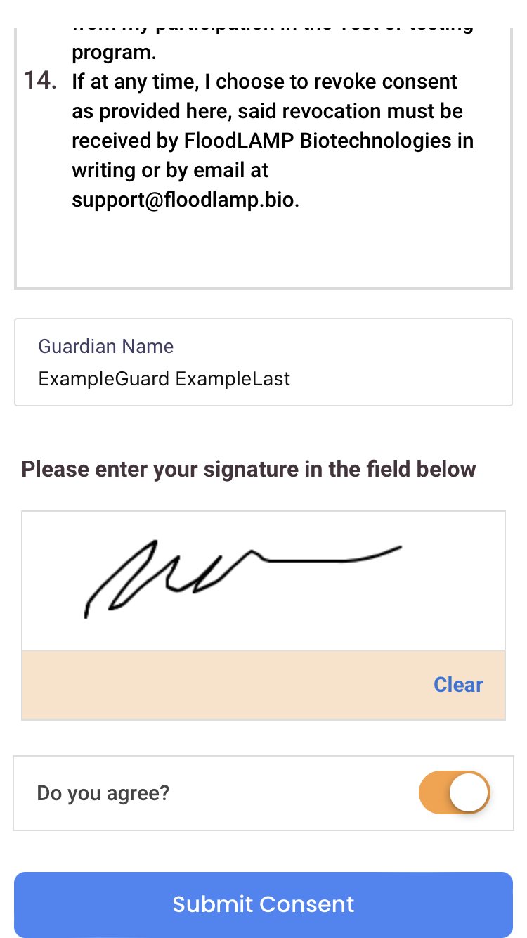

Repeat these steps to add each minor individually until all household minors are added. At this stage, you’re all set up to participate in the program!

Once the minor(s) have been linked to your profile, you will be able to add them through the app each time you collect samples for testing. In the Collection screen, they will appear under the name of the account to which they were added. To find them, simply search for your name and their name will appear underneath yours in the search list.
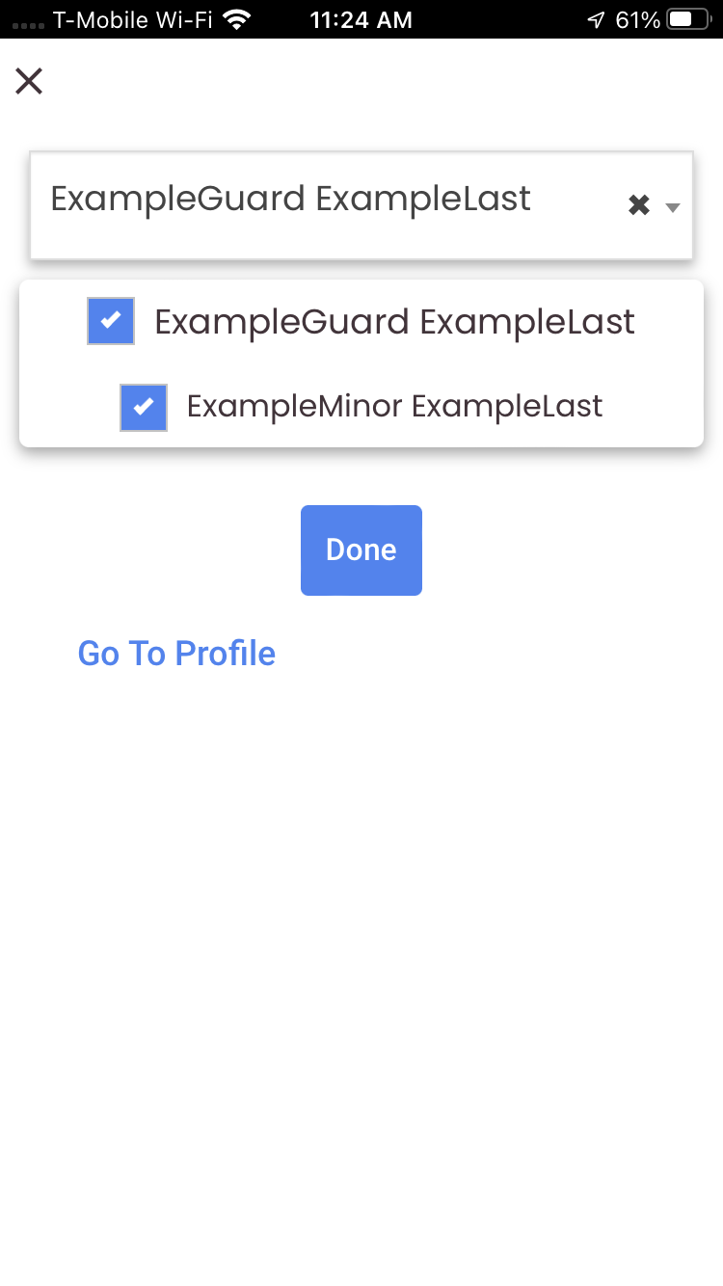
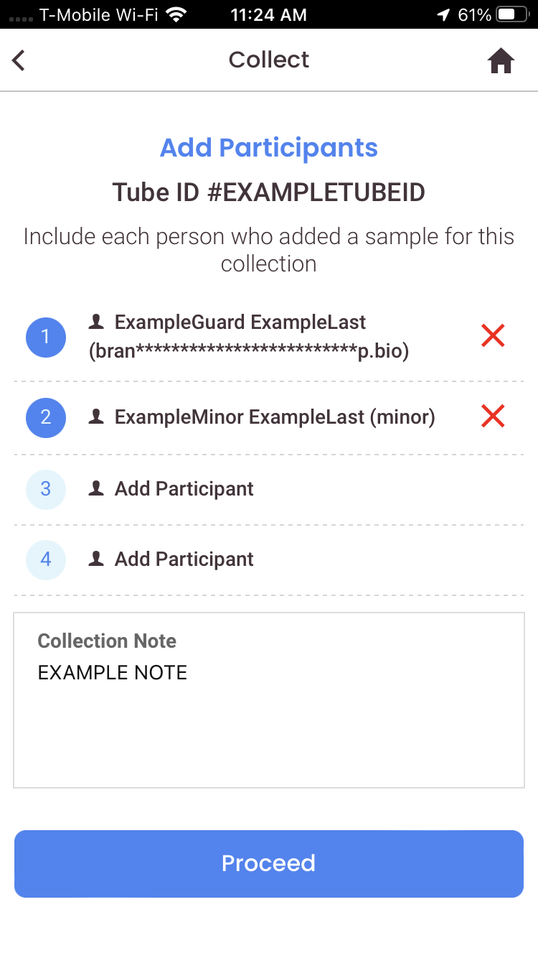
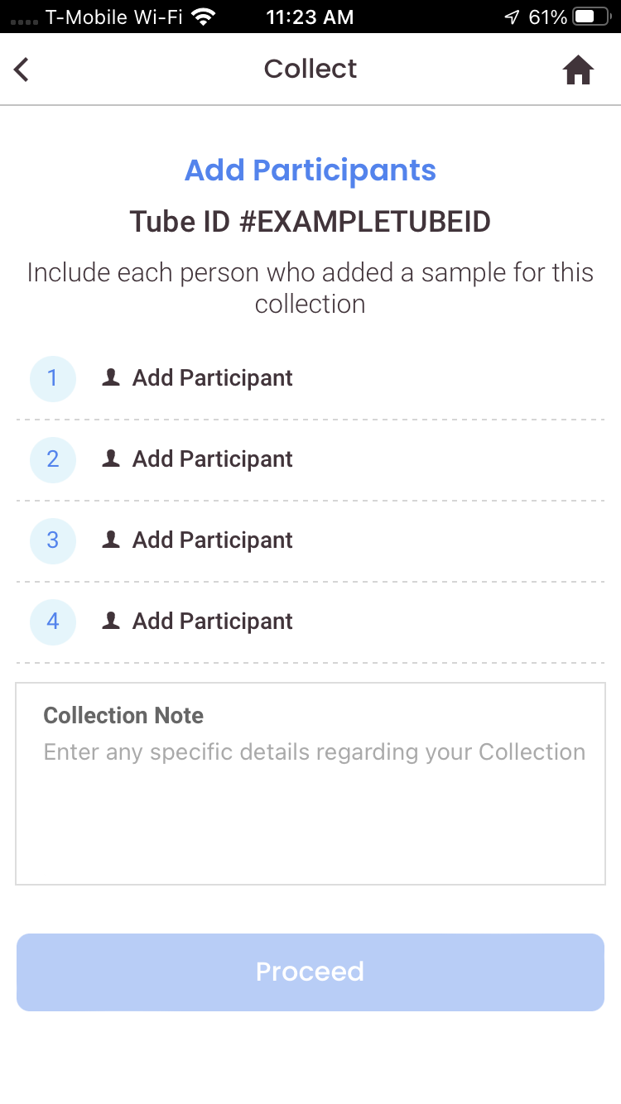

Please follow these steps to include each minor as a Participant when collecting your sample tube(s) for testing.

